3.1 Data Principal
A Data Principal is the individual whose personal data is being collected and processed. Under the DPDP Act 2023, the Data Principal has enforceable rights — including the right to access their data, correct inaccuracies, withdraw consent, and demand erasure.
For Eartigo, every user type maps to a Data Principal:
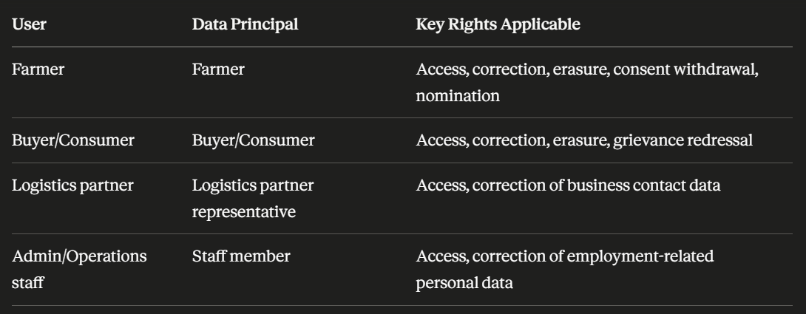

Practical implication for the team: Every API endpoint that touches personal data must be traceable back to a specific Data Principal. If a farmer requests erasure, the team must be able to identify and delete every record tied to that farmer across all collections — registration, KYC, orders, payout history, farm intelligence, consent logs (retain as proof), and support tickets.

3.2 Data Fiduciary — Eartigo's Role
A Data Fiduciary is the entity that determines the purpose and means of processing personal data. This is the most legally accountable role under the DPDP Act.
Eartigo acts as a Data Fiduciary when it:
- Decides to collect farmer Aadhaar references for KYC
- Determines that GPS boundary data will be used for digital twin creation
- Chooses to use satellite imagery for crop health analysis
- Sets the retention policy for payout records
As a Data Fiduciary, Eartigo must:
- Process personal data lawfully, transparently, and only for specified purposes
- Obtain free, specific, informed, unconditional, and unambiguous consent before processing
- Implement appropriate technical and organisational security safeguards
- Ensure accuracy of personal data
- Limit retention to what is necessary for the stated purpose
- Notify the Data Protection Board and affected Data Principals in the event of a breach
- Publish a Privacy Policy that is accessible, plain-language, and available in regional languages (important for farmer-facing content)
- Appoint a Consent Manager or equivalent mechanism for farmers to manage their consents
Significant Data Fiduciary consideration: If Eartigo is notified as a Significant Data Fiduciary (SDF) by the central government — which is likely given the volume of farmer financial and biometric-adjacent data — it will additionally need to appoint a Data Protection Officer (DPO), conduct Data Protection Impact Assessments (DPIAs), and undergo periodic audits.

3.3 Data Processors
A Data Processor is any entity that processes personal data on behalf of the Data Fiduciary, under a contract. Eartigo remains legally responsible for how its Data Processors handle data — a breach at a processor is still Eartigo's liability.
Every Data Processor relationship must be governed by a signed Data Processing Agreement (DPA) that specifies: permitted processing activities, data retention limits, security standards, breach notification obligations to Eartigo, sub-processing restrictions, and data deletion on contract termination.
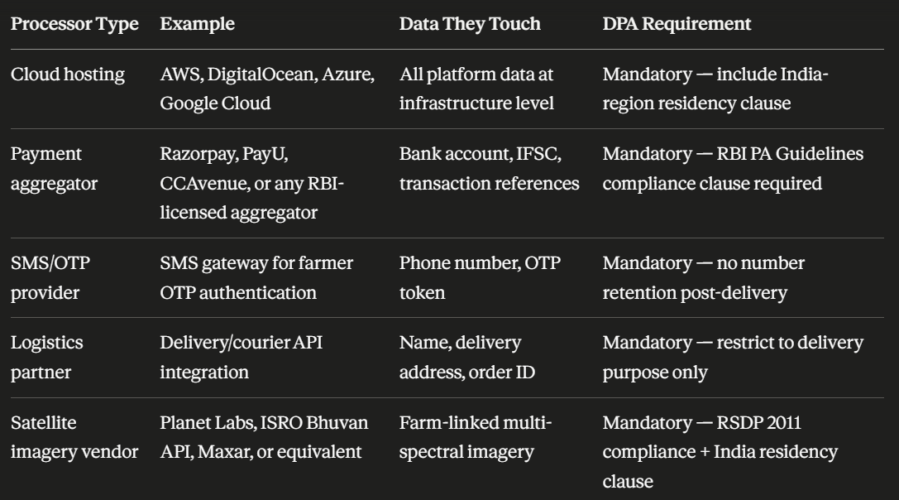
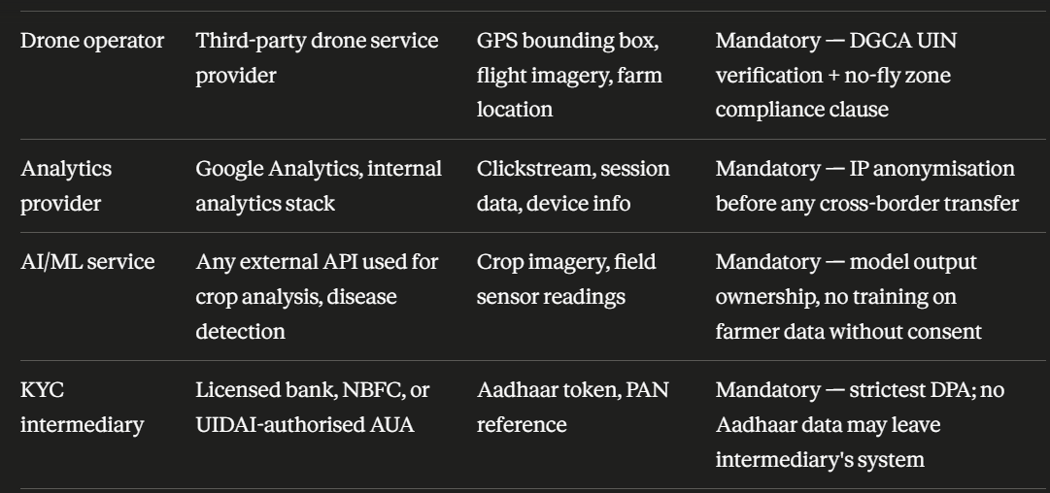

Key rule for the team: Before integrating any new third-party service, check whether it will touch personal data or farm intelligence data. If yes, a DPA must be signed and reviewed before go-live. No exceptions.

3.4 Consent Requirements
Consent under the DPDP Act 2023 must be free, specific, informed, unconditional, and unambiguous. For Eartigo, consent is not a single checkbox at registration — it must be granular, purpose-bound, and separately obtained for each distinct use of personal data.

What Valid Consent Looks Like
- Written in plain language the farmer can understand (consider regional language support — Kannada, Telugu, Hindi, Marathi depending on user base)
- States exactly what data is being collected
- States exactly why it is being collected
- States who it will be shared with
- Gives the farmer a genuine yes/no choice — withholding consent must not block access to core platform features where that data is not essential
- Can be withdrawn at any time, and withdrawal must be as easy as giving consent
- Each withdrawal must be acted upon promptly — processing must stop for that purpose

Consent Map for Eartigo

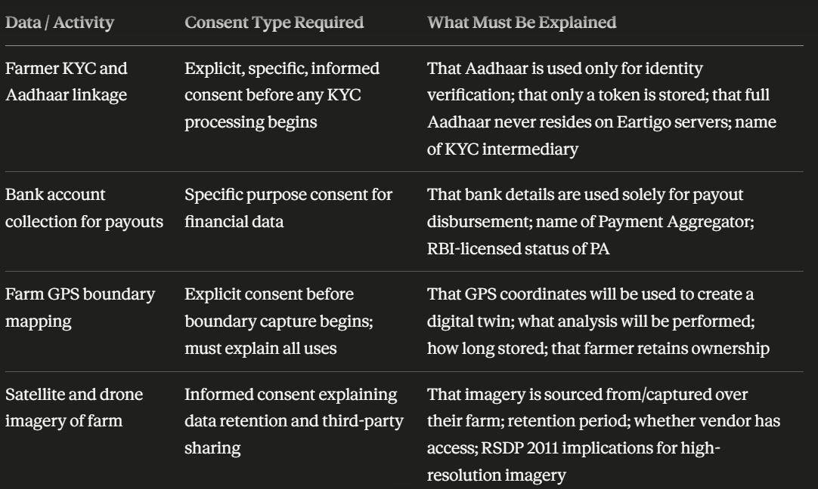
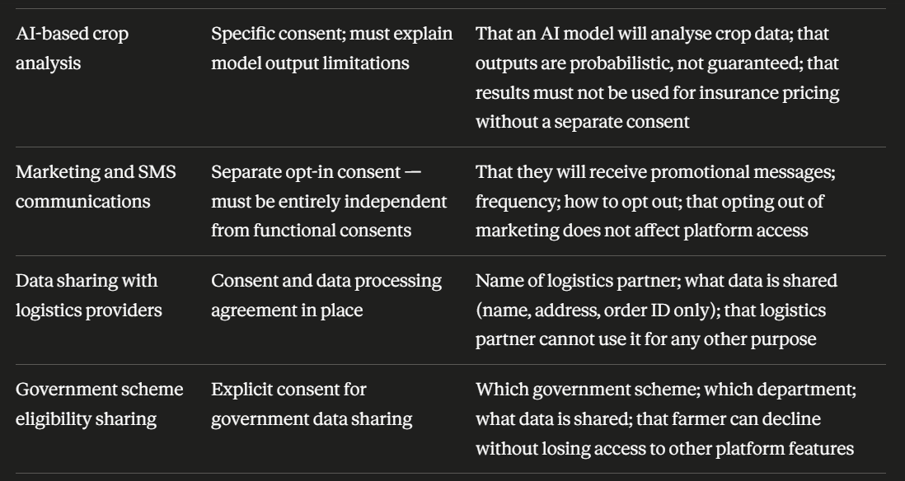
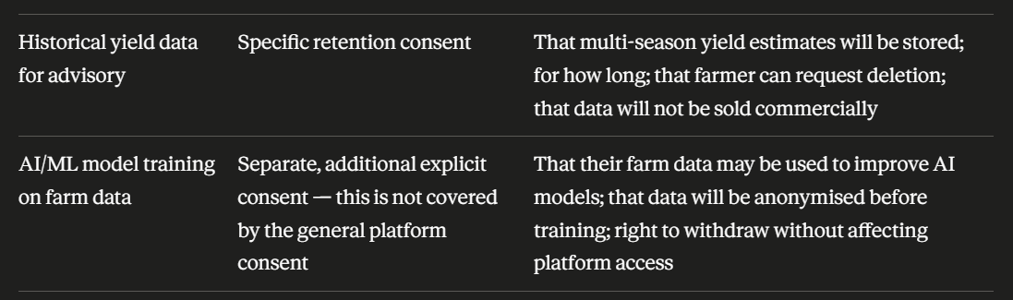

Consent Architecture Recommendation
The team should implement a Consent Management Module with the following properties:
- A consent_logs collection in MongoDB that is append-only — no updates or deletes permitted
- Each consent record must store: user_id, data_type, purpose, consented (boolean), timestamp (NTP-synced), ip_address, user_agent, consent_version (so you can track which version of the consent text was shown)
- A Consent Dashboard accessible to the farmer from their account where they can view all active consents and withdraw any of them individually
- When consent is withdrawn, a new record is appended with consented: false — the original consent record is never modified (audit integrity)
- The system must propagate withdrawal — if a farmer withdraws consent for GPS boundary use, the agri-intelligence engine must stop processing that farm's location data within a reasonable timeframe

3.5 Rights of Data Principals
The DPDP Act grants Data Principals the following rights, all of which Eartigo must operationalise:
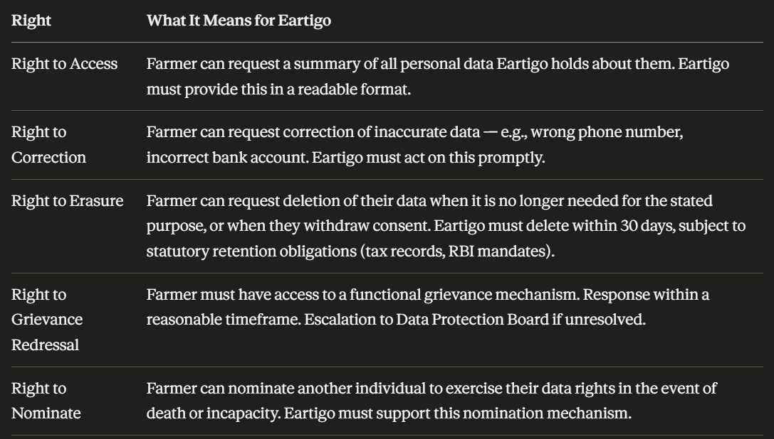
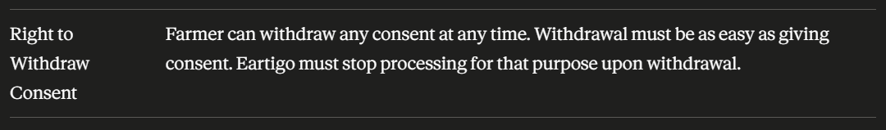

3.6 Obligations Upon a Data Breach
Under the DPDP Act 2023 and CERT-In Directions 2022, Eartigo has strict breach response obligations:
- CERT-In: Report specified cybersecurity incidents within 6 hours of becoming aware
- DPDP Act: Notify the Data Protection Board and affected Data Principals of a personal data breach without undue delay — the exact timeframe will be specified in rules, but best practice is 72 hours aligned with global standards
- Notification to affected farmers must be in plain language, explaining: what happened, what data was affected, what Eartigo is doing about it, and what the farmer should do
- Eartigo must maintain a breach register documenting all incidents — including near-misses — with timestamps, scope, and remediation actions
- Logs must be retained for 180 days minimum (CERT-In mandate) and must be NTP time-synced

3.7 Data Localisation Summary

